**Cyber bullying in online games（如何应对网络游戏的霸凌）**

Question 8 (Sub-question 5):Automatically identify and block illegal words (overall evaluation, 1 point is very bad) [Matrix question]

|  |  |  |  |  |  |  |  |  |
| --- | --- | --- | --- | --- | --- | --- | --- | --- |
| X\Y | don't know unknown | very worse | poor worse | normal | better nice | very nice very nice | Subtotal | The average score |
| Less than 4 hours | 18 (23.68%) | 9 (11.84%) | 12 (15.79%) | 15 (19.74%) | 18 (23.68%) | 4 (5.26%) | 76 | 2.93 |
| 4-8 hours (4-8 hours) | 3 (4.84%) | 2 (3.23%) | 14 (22.58%) | 23 (37.10%) | 15 (24.19%) | 5 (8.06%) | 62 | 3.12 |
| 8-14 hours (8-14 hours) | 6 (17.14%) | 3 (8.57%) | 8 (22.86%) | 12 (34.29%) | 4 (11.43%) | 2 (5.71%) | 35 | 2.79 |
| more than 14 hours | 1 (3.57%) | 5 (17.86%) | 4 (14.29%) | 7 (25%) | 8 (28.57%) | 3 (10.71%) | 28 | 3 |

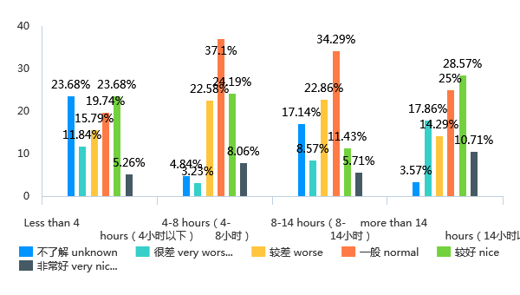

Question 10 (Sub-question 5):Report to the operator (overall evaluation, 1 point is very bad) [Matrix question]

|  |  |  |  |  |  |  |  |  |
| --- | --- | --- | --- | --- | --- | --- | --- | --- |
| X\Y | don't know unknow | very worse | poor worse | normal | better nice | very nice very nice | Subtotal | The average score |
| Less than 4 hours | 15 (19.74%) | 5 (6.58%) | 12 (15.79%) | 17 (22.37%) | 19 (25%) | 8 (10.53%) | 76 | 3.21 |
| 4-8 hours (4-8 hours) | 4 (6.45%) | 4 (6.45%) | 16 (25.81%) | 18 (29.03%) | 17 (27.42%) | 3 (4.84%) | 62 | 2.98 |
| 8-14 hours (8-14 hours) | 6 (17.14%) | 3 (8.57%) | 3 (8.57%) | 9 (25.71%) | 13 (37.14%) | 1 (2.86%) | 35 | 3.21 |
| more than 14 hours | 2 (7.14%) | 6 (21.43%) | 7 (25%) | 2 (7.14%) | 8 (28.57%) | 3 (10.71%) | 28 | 2.81 |

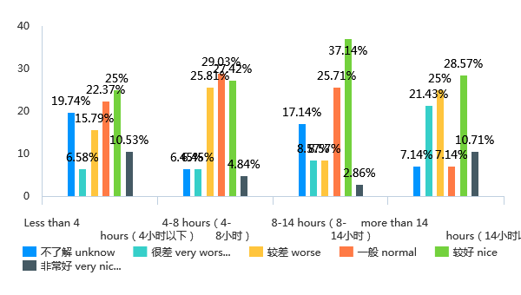

Question 12 (Sub-question 5):Player education, through creating a good game community atmosphere, allowing players to consciously maintain the game environment (overall evaluation, 1 point is very bad) )) [Matrix question]

|  |  |  |  |  |  |  |  |  |
| --- | --- | --- | --- | --- | --- | --- | --- | --- |
| X\Y | don't know unknow | very worse | poor worse | normal | better nice | very nice very nice | Subtotal | The average score |
| Less than 4 hours | 19 (25%) | 5 (6.58%) | 13 (17.11%) | 14 (18.42%) | 17 (22.37%) | 8 (10.53%) | 76 | 3.18 |
| 4-8 hours (4-8 hours) | 8 (12.90%) | 6 (9.68%) | 11 (17.74%) | 22 (35.48%) | 12 (19.35%) | 3 (4.84%) | 62 | 2.91 |
| 8-14 hours (8-14 hours) | 7 (20%) | 6 (17.14%) | 5 (14.29%) | 11 (31.43%) | 5 (14.29%) | 1 (2.86%) | 35 | 2.64 |
| more than 14 hours | 3 (10.71%) | 9 (32.14%) | 3 (10.71%) | 7 (25%) | 3 (10.71%) | 3 (10.71%) | 28 | 2.52 |

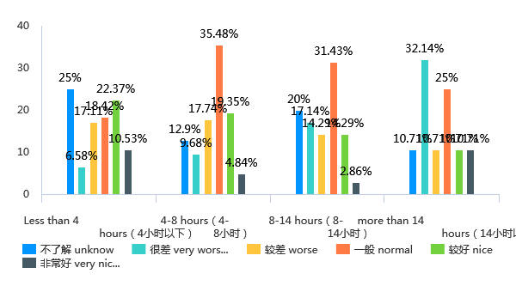

Question 14 (Sub-question 5):automated disciplinary system and player reform system in League of Legends (overall evaluation, 1 point is very bad) [Matrix question]

|  |  |  |  |  |  |  |  |  |
| --- | --- | --- | --- | --- | --- | --- | --- | --- |
| X\Y | don't know unknow | very worse | poor worse | normal | better nice | very nice very nice | Subtotal | The average score |
| Less than 4 hours | 4 (13.79%) | 2 (6.90%) | 4 (13.79%) | 5 (17.24%) | 7 (24.14%) | 7 (24.14%) | 29 | 3.52 |
| 4-8 hours (4-8 hours) | 3 (8.11%) | 3 (8.11%) | 8 (21.62%) | 13 (35.14%) | 10 (27.03%) | 0 (0.00%) | 37 | 2.88 |
| 8-14 hours (8-14 hours) | 4 (21.05%) | 1 (5.26%) | 2 (10.53%) | 7 (36.84%) | 2 (10.53%) | 3 (15.79%) | 19 | 3.27 |
| more than 14 hours | 5 (25%) | 1 (5%) | 5 (25%) | 4 (20%) | 2 (10%) | 3 (15%) | 20 | 3.07 |

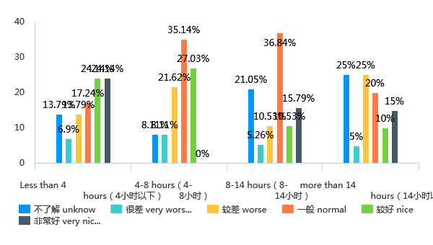

Question 16 (Sub-question 5):Block user, delete post and/or flag content when toxic behavior is occurring (overall evaluation, 1 point is very bad) [Matrix question]

|  |  |  |  |  |  |  |  |  |
| --- | --- | --- | --- | --- | --- | --- | --- | --- |
| X\Y | don't know unknow | very worse | poor worse | normal | better nice | very nice very nice | Subtotal | The average score |
| Less than 4 hours | 18 (23.68%) | 4 (5.26%) | 6 (7.89%) | 19 (25%) | 20 (26.32%) | 9 (11.84%) | 76 | 3.41 |
| 4-8 hours (4-8 hours) | 9 (14.52%) | 2 (3.23%) | 10 (16.13%) | 21 (33.87%) | 19 (30.65%) | 1 (1.61%) | 62 | 3.13 |
| 8-14 hours (8-14 hours) | 6 (17.14%) | 2 (5.71%) | 5 (14.29%) | 13 (37.14%) | 7 (20%) | 2 (5.71%) | 35 | 3.07 |
| more than 14 hours | 3 (10.71%) | 4 (14.29%) | 3 (10.71%) | 11 (39.29%) | 5 (17.86%) | 2 (7.14%) | 28 | 2.92 |

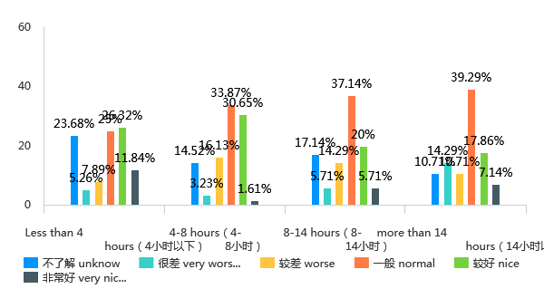

Question 18 (Sub-question 5):In-game rewards to encourage prosocial behavior in the gaming community（奖励主动维护游戏环境的行为，如成功举报不良行为，阻止霸凌等）（overall evaluation，1 point is very bad（总体评价）） [矩阵题]

|  |  |  |  |  |  |  |  |  |
| --- | --- | --- | --- | --- | --- | --- | --- | --- |
| X\Y | 不了解 unknow | 很差 very worse | 较差 worse | 一般 normal | 较好 nice | 非常好 very nice | 小计 | 平均分 |
| Less than 4 hours（4小时以下） | 19(25%) | 3(3.95%) | 9(11.84%) | 11(14.47%) | 21(27.63%) | 13(17.11%) | 76 | 2.67 |
| 4-8 hours（4-8小时） | 5(8.06%) | 5(8.06%) | 8(12.90%) | 20(32.26%) | 22(35.48%) | 2(3.23%) | 62 | 2.89 |
| 8-14 hours（8-14小时） | 6(17.14%) | 2(5.71%) | 4(11.43%) | 5(14.29%) | 11(31.43%) | 7(20%) | 35 | 2.97 |
| more than 14 hours（14小时以上） | 2(7.14%) | 4(14.29%) | 2(7.14%) | 8(28.57%) | 9(32.14%) | 3(10.71%) | 28 | 2.96 |

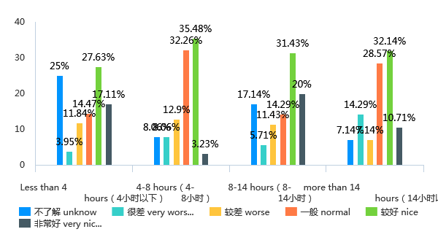

第20题（第5小题）：Temporary or permanent ban and/or forced withdrawal from game if found at fault（对于行为恶劣的霸凌行为进行封号处理）（overall evaluation，1 point is very bad（总体评价）） [矩阵题]

|  |  |  |  |  |  |  |  |  |
| --- | --- | --- | --- | --- | --- | --- | --- | --- |
| X\Y | 不了解 unknow | 很差 very worse | 较差 worse | 一般 normal | 较好 nice | 非常好 very nice | 小计 | 平均分 |
| Less than 4 hours（4小时以下） | 17(22.37%) | 3(3.95%) | 7(9.21%) | 18(23.68%) | 17(22.37%) | 14(18.42%) | 76 | 2.75 |
| 4-8 hours（4-8小时） | 4 (6.45%) | 4 (6.45%) | 5 (8.06%) | 28 (45.16%) | 17 (27.42%) | 4 (6.45%) | 62 | 3 |
| 8-14 hours (8-14 hours) | 6 (17.14%) | 0 (0.00%) | 2 (5.71%) | 8 (22.86%) | 10 (28.57%) | 9 (25.71%) | 35 | 3.23 |
| more than 14 hours | 2 (7.14%) | 3 (10.71%) | 2 (7.14%) | 9 (32.14%) | 7 (25%) | 5 (17.86%) | 28 | 3.11 |

